Welcome to
The Church Street Dental Practice
Quality Dental Care
Our aim is to leave you with a healthy natural looking smile!
The clinical team will be there to treat all your gum and tooth problems using the latest technology to ensure your journey is smoother and more comfortable than anything you’ve experienced before.
Every treatment is tailored to you, the patient. Whether it’s getting ready for an upcoming wedding, or you’ve lost confidence in your smile, The Church Street Dental Practice is the place for you.

This personal dental care does mean that we need to know a little more about you, so we hope that you will help us by completing the questions in this form.

All replies are in strictest confidence between yourself and the practice. Please feel welcome to raise any other queries or make any comments at any time.

Thank you for your help.

Full Name (Prof/Dr/Mr/Mrs/Miss/Ms/Other) ____________________________________________

Address__________________________________________________________________________

___________________________________________ Post Code_____________________________

Date of Birth________________________ Occupation____________________________________

Home Phone No._____________________ Daytime Phone No._____________________________

E-Mail Address_______________________

Doctor’s Name, Address and Telephone Number__________________________________________

________________________________________________________________________________

How did you come to choose our practice?

recommendation by a friend or relative (please name) _______________________________

Web Search / Denplan / NHS Choices / Google Ad / Instagram / Other (please specify)

________________________________________________________

Your General Health (please use the back of this sheet to give additional information)

1. Are you taking any medicines / pills / potions? (please list) _____________________________

_______________________________________________________________________________
2. Are you presently under any medical care YES/NO
_______________________________________________________________________________

3. Have you ever had any of the following

Rheumatic Fever YES/NO

Congenital heart lesion / Cardiac pacemaker; YES/NO

Heart attack / Angina; YES/NO

Blood pressure: High ____ or Low ____ (please tick); YES/NO

Jaundice, Infective Hepatitis, Liver Disease; YES/NO

Diabetes-Low blood sugar; YES/NO

Hiatus Hernia / Recurrent stomach trouble; YES/NO

Epilepsy; YES/NO

Bronchitis, Asthma, or any kind of Chest Problems; YES/NO

Digestive Problems; YES/NO

4. Have you ever had Radiotherapy or Chemotherapy? YES/NO

5. Have you ever had any ill effects following dental treatment? YES/NO

6. Have you had any ill effects from local anaesthetic? YES/NO

7. Have you had serious bleeding problems following an extraction? YES/NO

8. Have you ever had a positive result to a blood test for H.I.V.? YES/NO

9. Do you suffer with hayfever or asthma? YES/NO

10. Do you have sinus problems? YES/NO

11. Are you allergic to penicillin or any other antibiotics? YES/NO

12. Are you allergic to, or made ill by, any medication? YES/NO

13. Do you regularly take aspirin or any similar medication? YES/NO

14. Have you had any ill effects from aspirin? YES/NO

15. Have you been in hospital for observation or had any serious illness or major operation

(please specify)? _____________________________________________ YES/NO

16. Have you ever had dizziness, blackouts, giddiness or fainting? YES/NO

17. Are you pregnant or have had a baby within the last year? YES/NO

ABOUT YOUR DENTAL HEALTH (please use the back of this sheet to give any additional information)

Pain (If you need to answer “Yes” to any of these questions, please state where the pain is)
Have you recently had any pain from any of your teeth or in your jaws? YES/NO
Are any teeth sensitive to hot or cold things? YES/NO
Are any teeth sensitive to sweet things? YES/NO
Are any teeth tender when you bite or chew? YES/NO
Are any teeth sensitive to touch? YES/NO
Are you aware of any sharp edges or chipped teeth in your mouth? YES/NO
Do you try to avoid using certain teeth? YES/NO

Gums
“More adult teeth are lost through gum disease than through tooth decay”
Do you get a bad taste in your mouth or a bad smell to your breath? YES/NO
Do your gums bleed when you brush your teeth? YES/NO
Are your gums ever tender or sensitive? YES/NO
Are you aware of any areas where your gum is receding or shrinking? YES/NO
Does food get trapped between your teeth or gums? YES/NO

Appearance
Are you happy with the appearance of your teeth? YES/NO
Is there anything about the colour, shape or position of your teeth that you would like to
improve or discuss? YES/NO

Dentures
If you wear dentures, how happy with them are you at the present time? YES/NO
VERY / FAIRLY / NOT AT ALL / ___________________________________________

Other
Do you find it difficult to eat, bite or chew your food properly? YES/NO
Do you suffer from headache, migraine or pains in your face, cheek or in your ear? YES/NO
Does your jaw ever “click” or get stuck (further questions overleaf)? YES/NO
Do you suffer from any ulcers or any areas that are sore or swollen in your mouth? YES/NO
Do any of your teeth feel loose? YES/NO
Are there any other problems you would like to discuss with us? YES/NO

OCCLUSION

For most of us, the way in which our teeth meet is not in total harmony with the jaw joints. Normally we are able to cope with these discrepancies most of the time and we therefore function perfectly well.

However, if further physical or emotional stress is added to the system this can tip the balance out of harmony causing a variety of symptoms to develop around the head and neck. Some of these symptoms can seem to be totally unrelated to teeth and can even have been grumbling away for quite some time.

Please be as frank as possible with your answers to the following questions.

Jaw Joint

Do your jaw joints ever click/pop when you open and close? YES/NO

If “YES”, do both of them click or just one? Right / Both / Left

Do you ever have difficulty opening wide or moving the jaw to one side? YES/NO

Teeth / Jaw

Do you clench or grind your teeth during the day? YES/NO

Do your teeth / jaw feel tired when you wake up? YES/NO

Are you made aware that you clench or grind your teeth during the night? YES/NO

General, of the head and neck

Do you suffer from chronic headaches? YES/NO

Which side of the mouth do you tend to chew with most? Right / Both / Left
Do you ever have pain in your jaw joints or around your head and neck? YES / NO
If “YES”, please indicate on these diagrams where that occurs.

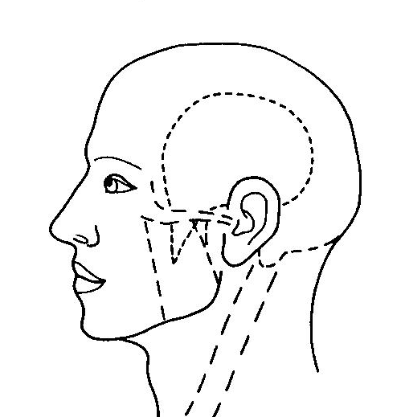
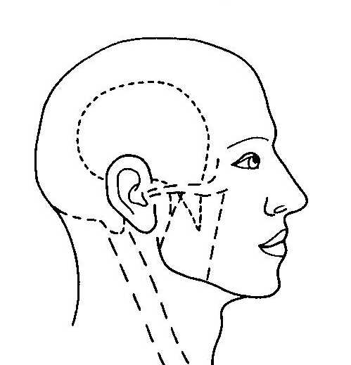
Right side Left Side

GETTING TO KNOW MORE ABOUT YOU

We believe in treating you as an individual person rather than as “just another patient”. Your frank answers to these questions will help us to get to know you and may well influence the actual treatment we need to provide for you.

How much do you worry about a dental visit? A LOT / A BIT / NOT REALLY / NOT AT ALL

What do you worry about most in a dental visit? (please give details) ________________________
_______________________________________________________________________________

What is the most convenient time/day for you? ________________________________________

How highly would you rate the importance of a good appearance for your mouth? VERY / FAIRLY / NOT AT ALL

How important is it for you to keep your own teeth? VERY / FAIRLY / NOT AT ALL
Do you take active steps to keep fit and healthy? YES/NO
Do you play contact sports or hazardous leisure activities? YES/NO
Do you smoke? YES/NO
How much alcohol do you normally consume per week? _____ units
Do you take sugar in drinks? YES/NO
Do you suck peppermints or eat other sweets on 2 or more days/week? YES/NO
Do you consider that you take diet and nutrition seriously? YES/NO
How much “hidden sugar” do you think is in your diet?
NOT SURE WHAT “HIDDEN SUGAR” IS / A LOT / A BIT / NOT MUCH / NONE
Do you play any woodwind instruments? YES/NO
Is there anything else you feel we should know about you and your life style?
_______________________________________________________________________________

“AND FINALLY, …” if a magic wand could be waved over your mouth, what would you want it to achieve? ___________________________________________________________________________________________________________________________________________________________________________________________________________________________________________________

If there is anything which you do not understand or need any help with please do not hesitate to ask. We are all here to help you.

Signed _______________________________________ Date ____________________________

Thank you for completing all these helpful questions. Please now return them to our receptionist.

